Chapter 1: Introduction

# 

# Chapter Outline

Develop the chapter outline here. Should become very detailed and broken down to paragraph level. Remember, if we invest time and effort into making a detailed outline, the actual writing will be far easier since we understand the flow and structure before we lay out the details. Before even writing a subsection, take the time to outline that subsection in the chapter outline. A lot of writing is in the layout. Remember to update this chapter in the Master Outline file so we can all keep track of the full outline of the report, its large so breaking it up this way should help everyone keep track of each other's ideas and work.

Project Background

* USGS Goals
* Advantages of Drone Data Collection
* Disadvantages of Drone Data Collection

Solutions

* DJI Matrice 600 Pro
* Zerone
* H-Aero
* The need for a better solution

What to Expect

* Results
* Report Layout

# Chapter 1 Draft

## 1.1 Project Background and Motivation

### 1.1.1 USGS Goals

Researchers at the United States Geological Survey (USGS) collect data of the Earth’s Earth’s Earth’s magnetic field over an area, and use magnetic anomalies in order to identify underground geological formation such as geysers, rivers, and mineral deposits. The area covered in each survey is large and not always easy to travel across, so the USGS has adopted the use of drones to carry a magnetometer payload to collect data[2]. Jonathan Glenn, a researcher with the USGS, conducts magnetic field surveys with drones and has provided the background information for the limitations and difficulties of using drones as data collection tools. The primary issue Glenn conveyed was the limited flight time; the current drone setup Glenn uses to collect data is limited to 15-minute flights and the drone must make 7 trips to cover the usual area they survey in a day[12]. Even with limited flight time, data collection with drones is invaluable.

In 2010 magnetic data was collected at Yellowstone National Park using both aerial and land based collection methods, around geologic anomalies such as Lone Star Geyser. This survey provided significant evidence that “a significant decrease of the substratum total magnetization is observed within altered zones”[1]. It finds that these anomalies can be used to map areas of hydrothermal alteration by searching areas characterized by this lower magnetism. This survey was able to provide data on different types of anomalies that would allow researchers to determine characteristics of that anomaly such as whether it is liquid dominated or its depth. Another survey in 2012 by USGS built on this by using UAS to reveal a more than “35km long linear, intra basin magnetic high”[2]. The unprecedented level of detail from this survey allowed for the discovery of several major hot springs that could be used for geothermal research and energy. “These findings could never have been substantiated by ground based data”[2].

The USGS notes that beyond providing more substantive evidence, surveys conducted by UAS had a multitude of benefits. UAS surveys are highly adaptable, compared to high resolution commercial surveys, that are “relatively inflexible to the need to change survey specifications that may arise as data [is] collected”[2]. UAS surveys have additional safety benefits for surveys that require low altitude flight paths that would pose risks to pilots of manned aerial vehicles.

Due to the successes of USGS experiments with UAS based magnetometer data collection, Jonathan Glen has expressed interest in further developments in technology that could benefit this method of data collection.

Jonathan Glenn and the USGS are only one example of the effects drone technology has on the research community. Drone technology is superior to older data collection methods in safety, sensor accuracy, and adaptability, and cannot be replaced, but drones have their limitations and those limitations need to be improved to further help researchers. We worked with Jonathan Glenn to define the needs of researchers based on his specific needs as our first test case. Jonathan Glenn is a potential client who has agreed to pay for a system that meets his needs, but also, he helps provide detailed information on the needs of researchers who use drones as a whole.

### 1.1.2 Advantages of Drone Data Collection

Drones have several major advantages over other methods of data collection, including safety, accessibility, sensor accuracy, and real-time monitoring.

Drones help to collect data when it is dangerous for humans to do so. Many tasks performed by people can be hazardous and even result in death, 5333 deaths in the United States during 2019 alone[8]. Drones help mitigate the risks by removing the operators away from potential danger; although drones can not be applied in every situation, accepting their use can help protect workers from injury and death. Drones are already being employed by businesses, and can perform thousands of dangerous tasks even in a single company[9]. Drone safety is only the beginning to their advantages.

Drones also increase accessibility to places that can be hard to reach with other data collection methods. Limited accessibility applies to several situations such as the tops of mountains, the inside of a volcanic eruption site[10] or near people. Other forms of aircraft, such as planes or helicopters, could be used to access these areas, but a lot of time and resources have to be allocated in order to use them, and there are potential issues of safety for the pilots and nearby people. With the use of a drone, people can access places in the form of an expendable, small, and easily controllable flying aircraft, and this is imperative when wanting to investigate something close to the ground, where manned aircraft cannot safely go.

Drones can also be used for real-time data monitoring. With the attachment of sensors onto a drone, a drone can easily capture the scene of an environment and record it for further analysis. These drones are even more useful when they provide live data back to the user, allowing the person to be far away from the area allowing a much faster means of recording data, by decreasing data collection times by improving accessibility through drone flight, in some cases reducing days or months of data collection to a few hours[11]. In turn, this allows for a more efficient workflow. Workplaces have used drones for this reason as well, and have seen substantial improvement in productivity.

### 1.1.3 Disadvantages of Drone Data Collection

Drones have a limited weight capacity, so a limited amount of onboard power is available, limiting drone flight time. Propulsion systems and wireless communication systems are two of the largest power draws on a drone, so they should be optimized to increase flight time as much as possible[5]. The propulsion system must be as energy efficient as possible to carry the drone over large distances and maintain flight as long as possible. Given a drone’s propulsion and electrical system, the maximum flight time will decrease as the drone carries heavier loads since more energy is required to maintain altitude. The communications system must be optimized due to its large power costs to transmit data, especially as the drone travels further from the user and further increases with increased amounts of data transmitted.

The USGS drone setup is designed to carry a magnetometer payload, which measures the magnetic field around it; precautions need to be made to reduce the magnetic interference. The greater the generated magnetic field of the motors is and the closer the motors are to the magnetometer, the greater the interference will be causing an error in the magnetic field readings.

Drones are also vulnerable to outside forces such as drag, and this is heavily dependent on the design . Given that the drone must be light to be able to have the largest possible flight time, this also must be balanced with the wind that may push it around if it is too light. The aerodynamics of the drone may also have a dampening effect on the air resistance. Another cause of a collision may be caused by a user error with the controls. If a drone’s rotors are not sufficiently protected, any obstructions or collisions involving the rotors may cause the drone to cease to function and crash. A lighter drone will cause crashes to be more prevalent due to the drag force because of wind causing the drone to deviate from its desired path[6].

## 1.2 Current Solutions-DJI Matrice 600 Pro

The USGS currently uses the DJI Matrice 600 Pro for magnetometer data collection. The DJI Matrice is a hexacopter and is a drone designed to carry heavy payloads, up to 6 kg. The drone primarily suffers from a short flight time of 15 minutes\, due to the mass of the electronics, frame, and payload. To carry the large payload, the drone needs a powerful electrical system and large batteries, massively increasing the size of the drone, and a heavy frame to support the electronics, payload, and propulsion forces.

Table 1.1 DJI E2000 Powertrain Specifications [7]

| Part Name | Use | Number | Power | Mass | Dimensions | Total mass |
| --- | --- | --- | --- | --- | --- | --- |
| DJI 6010 | Propulsion motor | 6 | 5100 g (max thrust) | 230g | 66.7mm Diameter X 29.2mm | 1380g |
| DJI 2170R | Propeller | 6 | N/A | 58g | 21 in Diameter | 348g |
| ESC (Unnamed) | Motor Control | 6 | N/A | 90g (with cables) | 85 mm X 44 mm X 18mm | 540g |
| TB27S | Battery | 6 | 99.9 Wh (Storage) | 595g | Not Listed | 3570g |
| Total mass |  |  |  |  |  | 5838 g |

Table 1.2

DJI Matrice 600 Pro Specifications [7]

| Specification | Description |
| --- | --- |
| Assembled Drone Dimensions | 1668 mm X 1518 mm X 727 mm |
| Storage Drone Dimensions | 437 mm X 402mm X 553 mm |
| Total Mass | 9.5 kg |
| Wind Resistance | 8 m/s |
| Max Speed (no wind) | 40 mph |
| Max Payload | 6 kg |
| USGS Payload (Info Given by Jonathan Glenn) | 1 kg |

Table 1.1 summarizes the specifications of the DJI E2000 powertrain system, the onboard propulsion system for the DJI Matrice Pro. The propulsion system alone weighs almost 6 kg of the drone mass. The total max thrust is 30.6 kg in order to move the drone and payload of up to 6 kg, and this consumes large amounts of power, six 100Wh batteries per flight.

Table 1.2 looks at several important system wide performance specifications for the drone. The overall drone size during flight is fairly large, but the storage size is far smaller, at 26.1%, 26.5%, and 76.1% of the assembled size for length, width and height respectively. The total drone mass is also 9.5 kg, sixty-percent of which is dedicated to the propulsion system.

The drone also has the ability to operate in wind conditions of up to 8 m/s, and has a top speed of 40 mph in no wind conditions. These values are provided by the website for the drone, but these values can change depending on the wind resistance and moments created by the payload mass, position, and drag.

The drone itself is very impressive, boasting a powerful and fast propulsion system that can support large payloads, however, there are several shortcomings. When used by the USGS for collecting magnetometer data, it can only make fifteen minute long flights. This is largely due to the mass and forces of the propulsion system. A large portion of the energy expended during flight is just for counteracting its own flight mass. The drone is also designed to carry payloads of up to 6 kg, but the magnetometer only weighs 1 kg, so the drone isn’t designed to perform most efficiently for the magnetometer mass.

The drone is also very expensive, costing $6,599.00 at dronenerds.com. This is excluding spare batteries listed at $209.00 on the same site, and the drone needs six batteries for flight. The drone can also only make a 15 minute flight. The result is the drone must make around 7 flights in a day, requiring plenty of spare batteries, further increasing the cost.

Lastly, the drone has an extremely powerful propulsion system that generates large electromagnetic interference for the magnetometer payload.

The DJI Matrice Pro is a powerful drone, but it has a short flight time due to its weight and power consumption, and also generates magnetometer interference that interferes with the data collection that the USGS needs.

## 1.3 The Need for a Better Solution

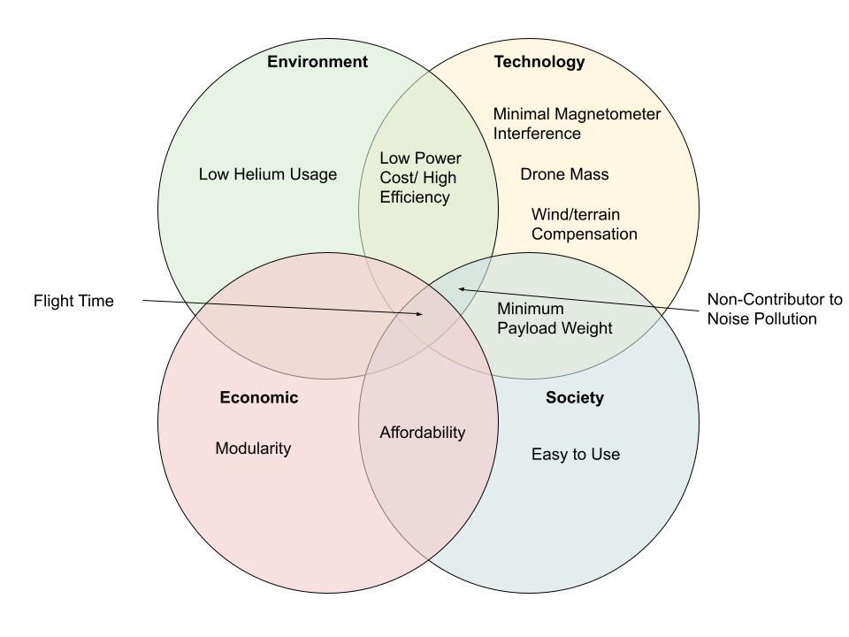

Figure 1.1. Four Lenses Project Analysis

The main goal of this project is to improve upon the total flight time tof drones and considers the four lenses perspective in Fig 1.1. To extend flight time, a lift bag is added to the drone to reduce the effective weight and energy needed to keep the drone afloat. The drag becomes a problem since the lift bag becomes large to compensate for any mass of the drone and payload but can be reduced by incorporating an aerodynamic design of the helium lift bag. The USGS’s magnetometer payload is the primary sensor attachment for the project, and the design will be based around that weight. We wish to also balance these requirements for improvement with other criteria, such as a low magnetometer interference of the drone motors. This will be done by making sure the motors are sufficiently far away from the actual payload to ensure minimal remnant magnetic field, as well as taking advantage of the fact that smaller motors, with a lower magnetic field, can be used due to the lower power required to maintain height. Also, given that helium has had shortages before and is a non-renewable resource, we need to ensure that any helium is used efficiently, meaning helium leakage must be minimized. This goes with our affordability requirement because we want our drone to be more power efficient than the competitor drones, as well as more cost efficient with our components.

## 1.3 What to Expect and Report Layout

The project was determined to be unsuccessful in meeting the requirements given by the USGS, but some analysis done shows it is possible and worth pursuing. The report covers the team’s design decisions, progress made, and verification tests of technical requirements, as well as individual and team reflections at the end of the report.

To begin the report, Chapter 2 establishes the physics introduced by incorporating a buoyant element to the drone design and uses the physical analysis to begin the high level design needed for the drone in order to incorporate buoyancy properly. Next, Chapter 3 introduces the lift bag design and frame design in order to meet all mounting requirements and force requirements that were presented in Chapter 2. Chapter 4 builds further on this, by introducing the design of the propulsion system in order to have a controllable drone for the performance requirements provided by USGS. Chapter 5 then goes over the sensor array and state estimation needed for the autonomous system development. Then, Chapter 6 combines the physics and state estimation of the previous chapters in order to deliver controllable flight in both Remote Control and Autonomous setups. Chapter 7 then analyzes the power requirements of the drone during flight, and lays out power distribution and estimates the total flight time. Chapter 8 attempts to use simulation to validate the design set forth throughout the previous chapters to ensure we could move forward with physical testing. Chapters 9 and 10 test the drone for verification of our requirements. Chapter 11 summarizes the legal and safety requirements required by the school, the FAA, and Covid19 regulations. Chapter 12 covers product costs and project funding. Chapter 13 makes final conclusions about the project, while Chapter 14 covers the next steps. Lastly, Chapter 15 is the appendix with reference charts, data, and sources that were useful in our project design, and will be useful for anyone else seeking to replicate or build upon our result. Throughout the documentation, the System Technical requirements are referenced, and the full document is included in the appendix.

Any reference to the System Technical Requirements is abbreviated by STR RequirementID, RequirementName for consistency due to their prevalence in a design report.

# 

# Chapter Bibliography

We do have a full bibliography that should absolutely be updated with all content here. The point of the chapter bibliography is to help keep track of citations in the chapter since the numbering may change in the full bibliography with changes and additions. This way will isolate the sources in this section so you can cite here without having to worry about it, and can use a simple find and replace on your citations to update the new numbering when we combine everything in the final report.

1. Bouligand, Claire. “Distribution of Buried Hydrothermal Alteration Deduced from High-Resolution Magnetic Surveys in Yellowstone National Park.” Journal Of Geophysical Research-Solid Earth, vol. 119, no. 4, AMER GEOPHYSICAL UNION, 2014, pp. 2595–630, doi:10.1002/2013JB010802.
2. J. M. G. Glen, A. E. Egger, C. Ippolito, and N. D. Athens, “Correlation of Geothermal Springs with Sub-Surface Fault Terminations Revealed by High-Resolution, UAV-acquired Magnetic Data,” p. 8.
3. W. Yamada, H, Manabe, and D. Ikeda “ZeRONE: Safety Drone with Blade-Free Propulsion,” thesis, Dept. Research Labs, NTT DOCOMO Yokosuka, Yokosuka, Kanagawa, Japan, 2019.
4. Yamada, Wataru, Hiroyuki Manabe, and Daizo Ikeda. ”Zerone: Safety drone with blade-free propulsion.” Proceedings of the 2019 CHI Conference on Human Factors in Computing Systems. 2019. Y
5. Yao, Jingjing, and Nirwan Ansari. ”QoS-aware power control in internet of drones for data collection service.” IEEE Transactions on Vehicular Technology 68.7 (2019): 6649- 6656.
6. Shoaxmedova, Nozima. ”IMPROVING DATA COLLECTION TECHNOLOGY IN RURAL AREAS USING DRONES.” 16 (2020).
7. “Matrice 600 Pro - Product Information - DJI.” DJI Official, www.dji.com/matrice600-pro/infospecs.
8. “Census of Fatal Occupational Injuries (CFOI) - Current and Revised Data.” U.S. Bureau of Labor Statistics, U.S. Bureau of Labor Statistics, 22 Dec. 2020, www.bls.gov/iif/oshcfoi1.htm2019.
9. Aug 12, 2019. “Companies Use Drones to Limit Dangerous, Potentially Fatal Tasks for Workers.” Occupational Health amp; Safety, ohsonline.com/articles/2019/08/12/companies-usedrones-to-limit-dangerous-potentially-fatal-tasks-forworkers.aspx?m=1&fbclid=IwAR1eD8a42VdW1WpK961 Q2xblDOFpSvY0p2C-QjOl7yS9bPC1009CVNR5ro.
10. Tarigan, A. P. M., et al. ”Mapping a volcano hazard area of Mount Sinabung using drone: preliminary results.” IOP Conference Series: Materials Science and Engineering. Vol. 180. No. 1. IOP Publishing, 2017.
11. “Data Capture with Drones – Digital Engineers’ Eyes in the Sky.” Aurecon, www.aurecongroup.com/expertise/digital-engineeringand-advisory/data-capture-drones.
12. Keller, Gordon. “Re: Long Flight Time Buoyant Drone.” Message to Dylan Arius Harootunian. 24 Nov 2021. E-mail.